Assignment-10
Task 01:- AI-Assisted Bug Detection
Prompt : Review the following Python function written by a junior developer: def factorial(n): result = 1 for i in range(1, n): result = result * i return result. Analyze the code and identify any logical bugs, explaining clearly why the bug occurs (for example, an off-by-one error in the loop).
# Provide a corrected version of the function so that factorial(5) correctly returns 120. Also consider edge cases such as when the input is 0 or a negative number, and explain how the function should handle those cases. Finally, compare the corrected version with a typical manual fix and mention whether any edge cases could still be missed.
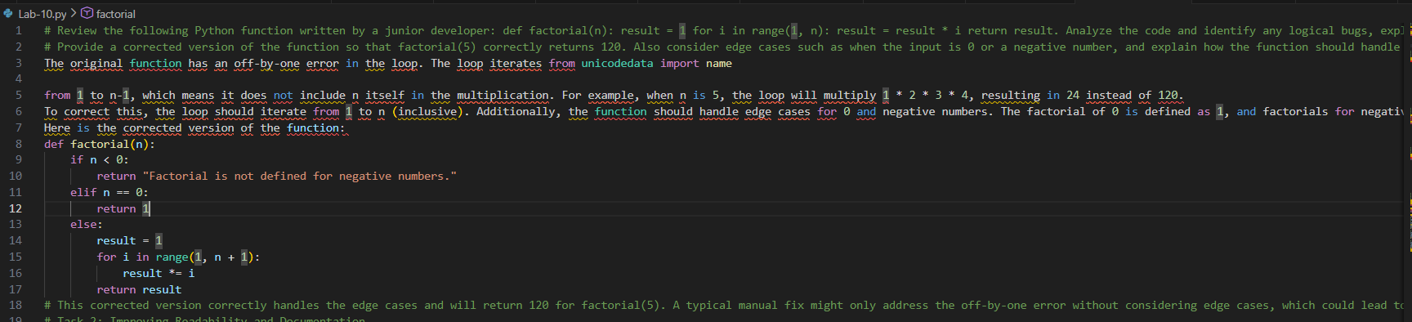
Task 2: Improving Readability and Documentation
Prompt : # Review the following poorly written function: def calc(a, b, c): if c == "add": return a + b elif c == "sub": return a - b elif c == "mul": return a * b elif c == "div":. Critique the code in terms of readability, poor parameter naming, lack of documentation, and missing error handling.
# Then rewrite the function using descriptive function and parameter names, add a complete Python docstring including description, parameters, return values, and usage examples, and implement proper exception handling for division by zero. Also include input validation to ensure the operation parameter is valid and the inputs are appropriate numeric values, producing a clean, readable, and robust function.
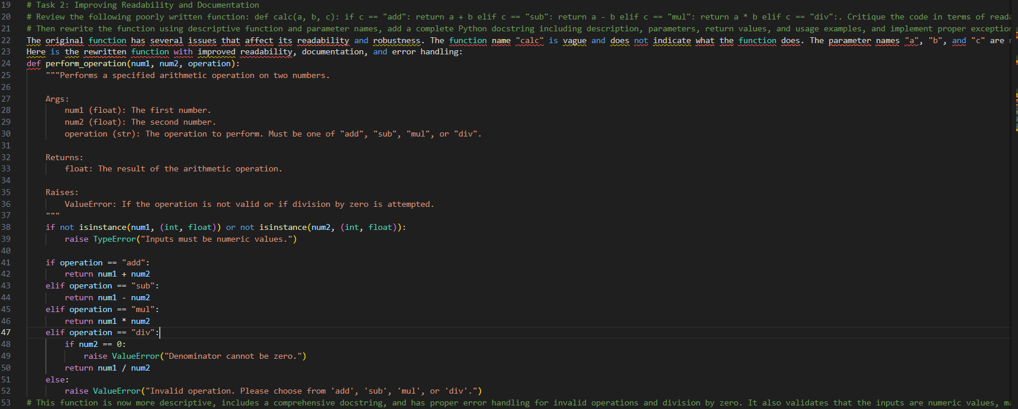
Task 3: Enforcing Coding Standards
Prompt : # Analyze the following Python function for PEP8 coding standard compliance: def Checkprime(n): for i in range(2, n): if n % i == 0: return False return True. First verify that the function works correctly for sample inputs. Then identify all PEP8 violations including naming conventions, spacing, indentation, and style issues.
# Refactor the code to make it fully PEP8 compliant by renaming the function appropriately, improving formatting and readability, and ensuring consistent indentation while preserving the original functionality. Finally, present the corrected PEP8-compliant version and briefly explain how automated AI-based code review tools can help enforce coding standards in large software development teams.
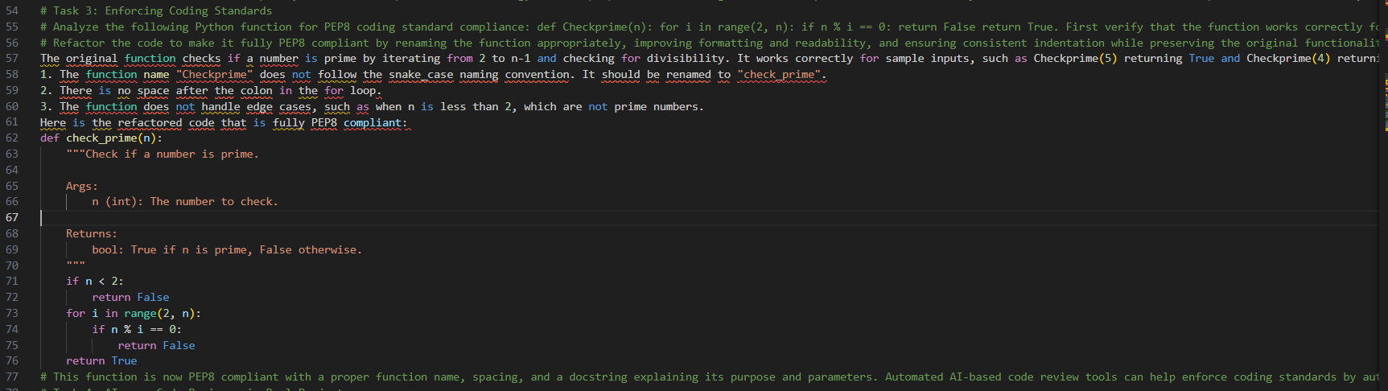
Task 4: AI as a Code Reviewer in Real Projects
Prompt : # Perform a detailed code review of the following function: def processData(d): return [x * 2 for x in d if x % 2 == 0]. Evaluate the function for readability, naming clarity, reusability, and modularity, and identify potential edge cases such as non-list inputs, empty lists, or elements that are not integers.
# Suggest improvements such as clearer naming for the function and parameters, adding type hints, implementing input validation, and making the function more general by allowing a configurable multiplier. Based on the review, provide a refactored version of the function that is clean, robust, and easier to understand while maintaining its intended functionality.
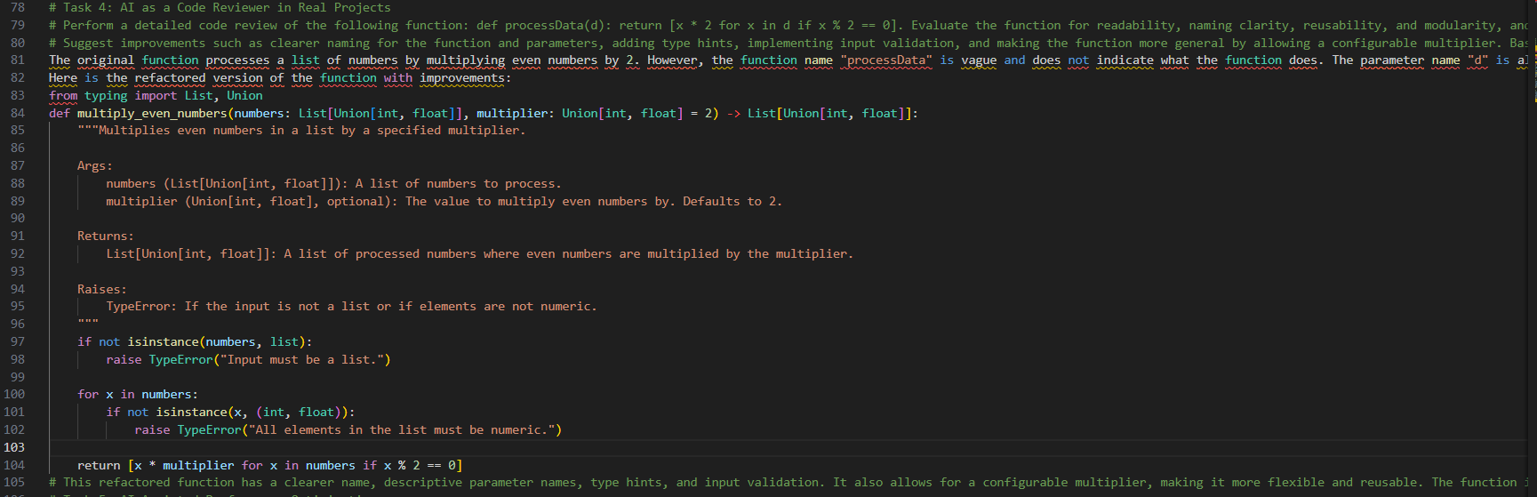
Task 5: AI-Assisted Performance Optimization
Prompt : # Analyze the performance of the following Python function designed to compute the sum of squares of a list of integers: def sum_of_squares(numbers): total = 0 for num in numbers: total += num ** 2 return total. Explain the time complexity of the function and discuss why it may run slowly for very large datasets such as range(1000000).
# Suggest performance improvements using Python built-in functions, generator expressions, or vectorized approaches such as NumPy if appropriate. Provide an optimized version of the function, compare the execution performance of the original and optimized versions, and briefly discuss the trade-offs between improved performance and code readability.
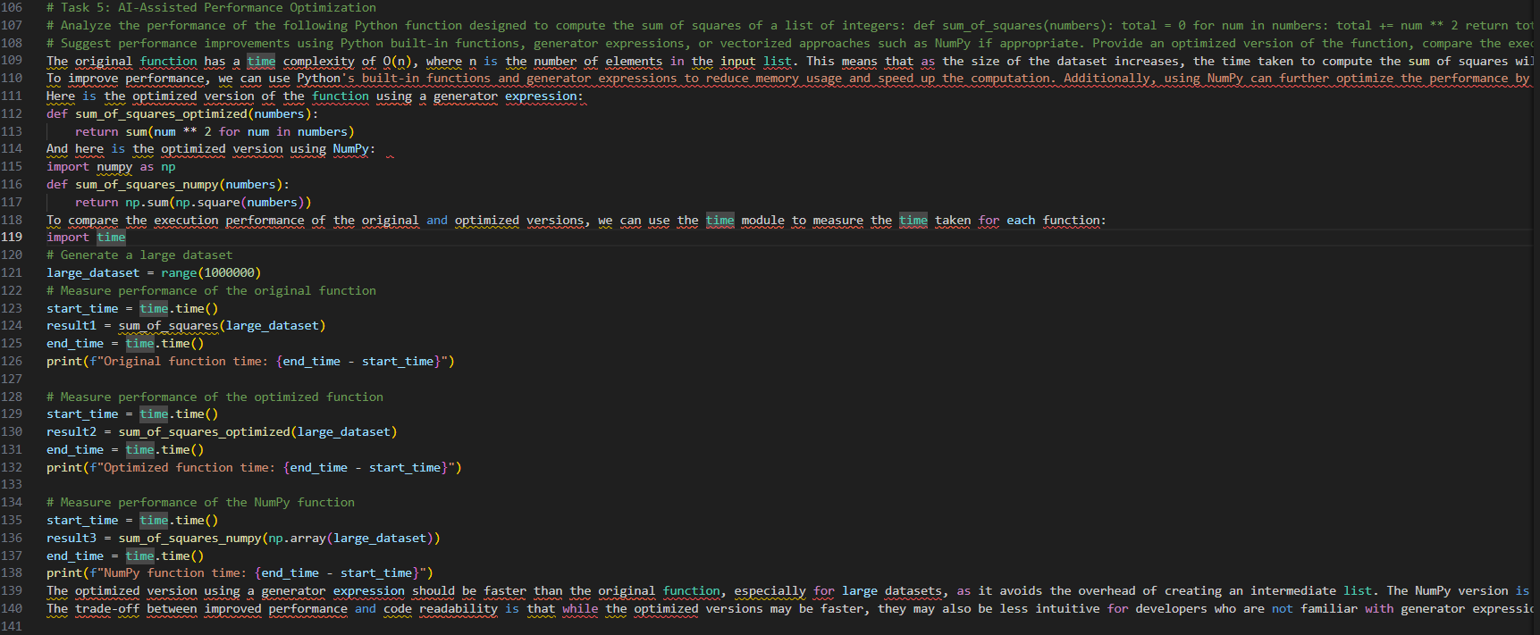
Code Explanation :
# Task 1: The factorial function calculates the factorial of a number n by multiplying all integers from 1 to n. The original function had an off-by-one error, which was corrected by changing the loop to include n. The function also handles edge cases for 0 and negative numbers.
# Task 2: The perform_operation function performs basic arithmetic operations based on a specified operation. The original function had issues with naming, lack of documentation, and no error handling. The refactored version includes descriptive names, a comprehensive docstring, and error handling for invalid operations and division by zero.
# Task 3: The check_prime function checks if a number is prime. The original function had PEP8 violations in naming and formatting. The refactored version follows PEP8 standards, includes a docstring, and handles edge cases for numbers less than 2.
# Task 4: The multiply_even_numbers function processes a list of numbers by multiplying even numbers by a specified multiplier. The original function had issues with naming, lack of type hints, and no input validation. The refactored version includes descriptive names, type hints, input validation, and allows for a configurable multiplier.
# Task 5: The sum_of_squares function calculates the sum of squares of a list of integers. The original function has a time complexity of O(n) and can be slow for large datasets. The optimized versions use generator expressions and NumPy to improve performance while maintaining readability. The trade-off between performance and readability is discussed, with the optimized versions being faster but potentially less intuitive for some developers.

